Name: Brihat Ratna Bajracharya
Roll No.: 19/075
Exercise 5 (Image Processing and Pattern Recognition)

A. Morphological Image Processing

Ques1. Explain dilation and erosion, two fundamental operations in mathematical morphology.

Answer

Dilation:
Dilation is an operation that grows objects in a binary image. The thickening is controlled by a small structuring element.

Erosion:
Erosion shrinks or thins objects in a binary image. After erosion, the only pixels that survive are those where the structuring element fits entirely in the foreground.

Ques2. [2.1.] Load 'broken-text.tif'. Dilate the image with different structuring elements. And see the different results. [2.2.] Do the same with noisy-fingerprint.tif

Solution

clearall;

% bt = imread('broken-text.tif');
bt = imread('noisy_fingerprint.tif');

figure
subplot(2,4,1);
imshow(bt);
% title('Original broken-text.tif');
title('Original noisy-fingerprint.tif');

% Structuring Elements
se1 = strel('square',3); % 11-by-11 square
se2 = strel('line',5,45); % line, length 10, angle 45 degrees
se3 = strel('disk',5); % disk, radius 15
se4 = strel('rectangle', [2 2]);
se5 = strel('octagon',3);

% Dilation
B = [0 1 0; 1 1 1; 0 1 0];
bt_dil = imdilate(bt, B);
subplot(2,4,2);
imshow(bt_dil);
title('Dilated by 3x3 matrix');

bt_dil = imdilate(bt, se1);
subplot(2,4,3);
imshow(bt_dil,'InitialMagnification','fit');
title('Dilated by square SE');

bt_dil = imdilate(bt, se2);
subplot(2,4,4);
imshow(bt_dil,'InitialMagnification','fit');
title('Dilated by line SE');

bt_dil = imdilate(bt, se3);
subplot(2,4,5);
imshow(bt_dil,'InitialMagnification','fit');
title('Dilated by disk SE');

bt_dil = imdilate(bt, se4);
subplot(2,4,6);
imshow(bt_dil,'InitialMagnification','fit');
title('Dilated by rectangle SE');

bt_dil = imdilate(bt, se5);
subplot(2,4,7);
imshow(bt_dil,'InitialMagnification','fit');
title('Dilated by octagon SE');

Output
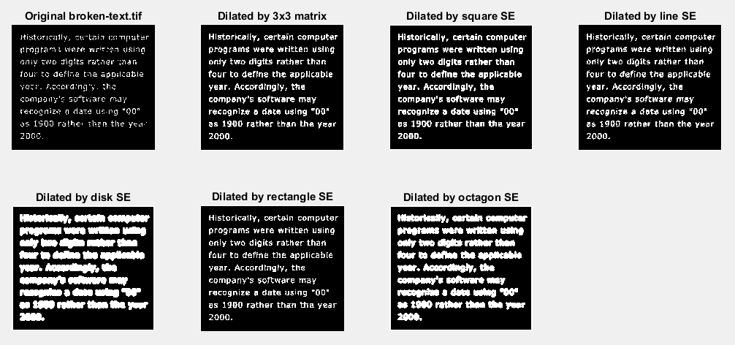Figure 1: broken-text.tif dilation under different structuring element
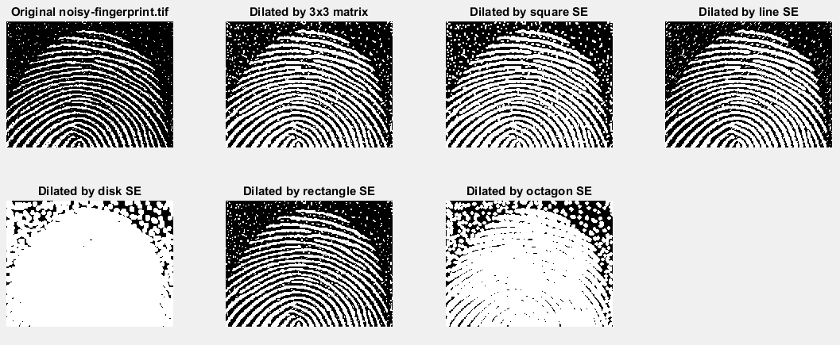Figure 2: noisy-fingerprint.tif dilation under different structuring element

Ques3. Load noisy-fingerprint.tif and broken-text.tif. Apply different erosions

Solution

clearall;

% bt = imread('broken-text.tif');
bt = imread('noisy_fingerprint.tif');

figure
subplot(2,4,1);
imshow(bt);
% title('Original broken-text.tif');
title('Original noisy-fingerprint.tif');

% Structuring Elements
se1 = strel('square',3); % 11-by-11 square
se2 = strel('line',5,45); % line, length 10, angle 45 degrees
se3 = strel('disk',5); % disk, radius 15
se4 = strel('rectangle', [2 2]);
se5 = strel('octagon',3);

% Erosion
B = [0 1 0; 1 1 1; 0 1 0];
bt_ero = imerode(bt, B);
subplot(2,4,2);
imshow(bt_ero);
title('Erosion by 3x3 matrix');

bt_ero = imerode(bt, se1);
subplot(2,4,3);
imshow(bt_ero,'InitialMagnification','fit');
title('Erosion by square SE');

bt_ero = imerode(bt, se2);
subplot(2,4,4);
imshow(bt_ero,'InitialMagnification','fit');
title('Erosion by line SE');

bt_ero = imerode(bt, se3);
subplot(2,4,5);
imshow(bt_ero,'InitialMagnification','fit');
title('Erosion by disk SE');

bt_ero = imerode(bt, se4);
subplot(2,4,6);
imshow(bt_ero,'InitialMagnification','fit');
title('Erosion by rectangle SE');

bt_ero = imerode(bt, se5);
subplot(2,4,7);
imshow(bt_ero,'InitialMagnification','fit');
title('Erosion by octagon SE');

Output
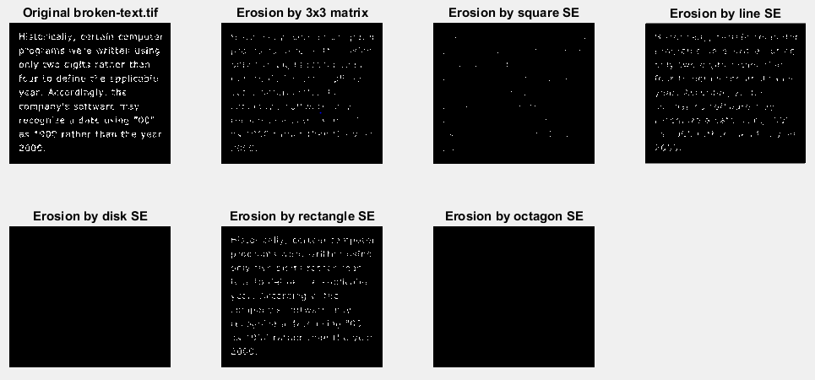Figure 3: broken-text.tif erosion under different structuring element
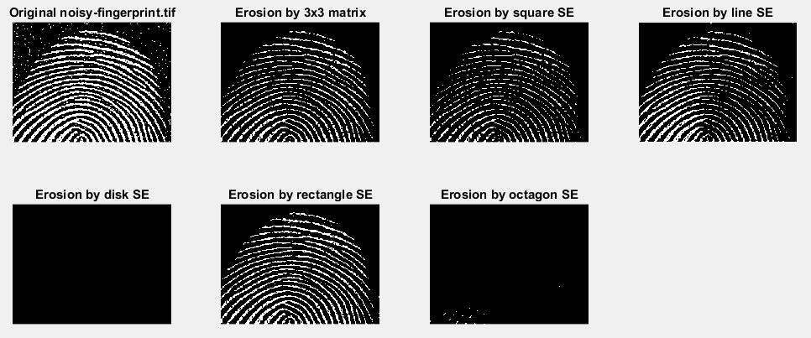Figure 4: noisy-fingerprint.tif erosion under different structuring element

B. Opening and Closing

Ques4. Reopen rice.png. Use imopen to eliminate all the rice grains. Convert all numbers so that they are between 0 and 1. Use mesh to view image (see details of ‘mesh’ command in help section). Use this new array to modify the original rice.png. Is it easier or harder to correctly pick all the rice grains.? How does the quantitation compare?

Solution

clearall;

I = imread('rice.png');
figure
subplot(2,2,1);
imshow(I);
title('Original');

% se = [0 1 0; 1 1 1; 0 1 0];
SE = strel('square',13 );
elim_rice = imopen(I, SE);
subplot(2,2,2);
imshow(elim_rice);
title('No Rice Grain');

J = filter2(fspecial('sobel'),I);
min_matrix = min(J(:));
max_matrix = max(J(:));

subplot(2,2,3);
imshow(J);
title('Converting to num matrix');

K = mat2gray(J);
min_image = min(K(:));
max_image = max(K(:));

subplot(2,2,4);
imshow(K);
title('Range [0,1]');

figure
mesh(K);

Output
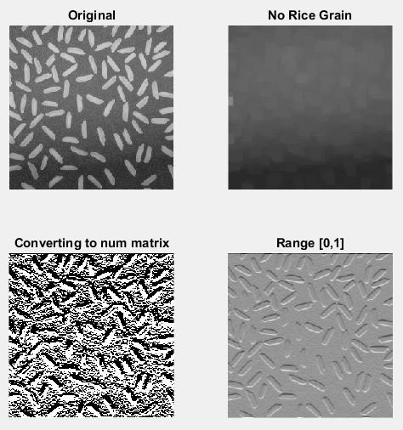Figure 5: Solution to Question 4
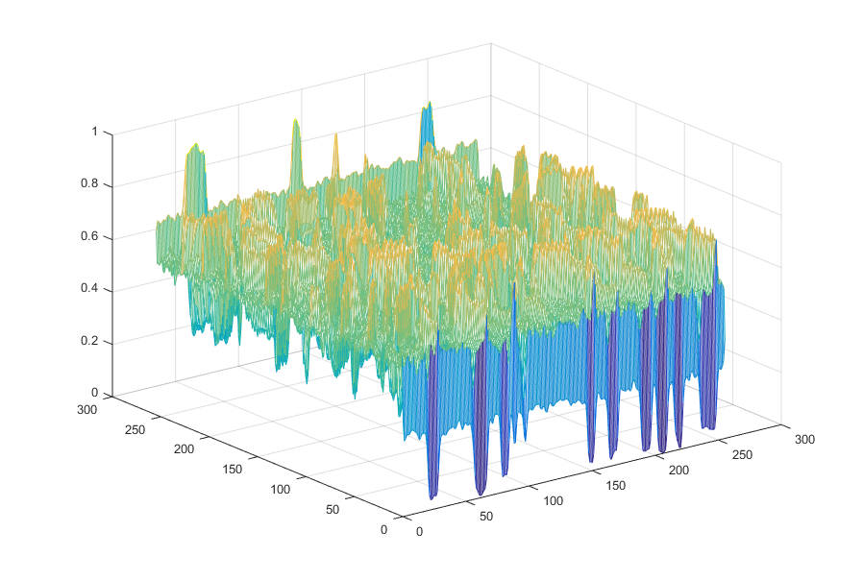Figure 6: Question 4 (rice.png in range [0,1] mesh)

Ques5. Load and apply opening and closing to noisy-fingerprint.tif and brokentext.tif. Discuss the result.

Solution

clearall;
% f = imread('broken-text.tif');
f = imread('noisy_fingerprint.tif');
figure
subplot(2,2,1);
imshow(f);
title('Original');

se = [0 1 0; 1 1 1; 0 1 0];
% se = strel('square',20);
fo = imopen(f, se);
subplot(2,2,2);
imshow(fo);
title('Opening');

fc = imclose(f, se);
subplot(2,2,3);
imshow(fc);
title('Closing');
foc = imclose(fo, se);
subplot(2,2,4);
imshow(foc);
title('Opening and Closing');

Discussion
In case of broken-text.tif, Closing operation was better than Opening operation as the text is more readable in former. Also the Opening operation result is same to that of Opening operation followed by Closing operation.
In case of noisy-fingerprint.tif, Opening operation removed all the noise from the original image but Closing operation cannot do so. Similar to broken-text.tif, the Opening operation result is same as that of Opening operation followed by Closing operation.

Output
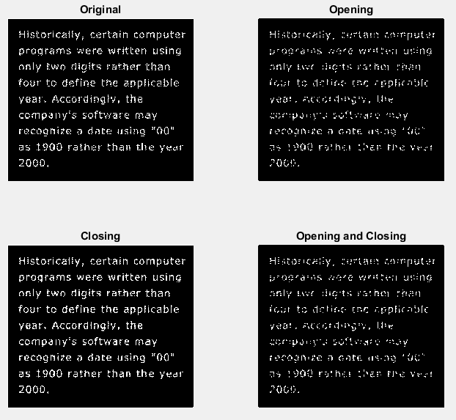Figure 7: Solution to Question 5 (for broken-text.tif)

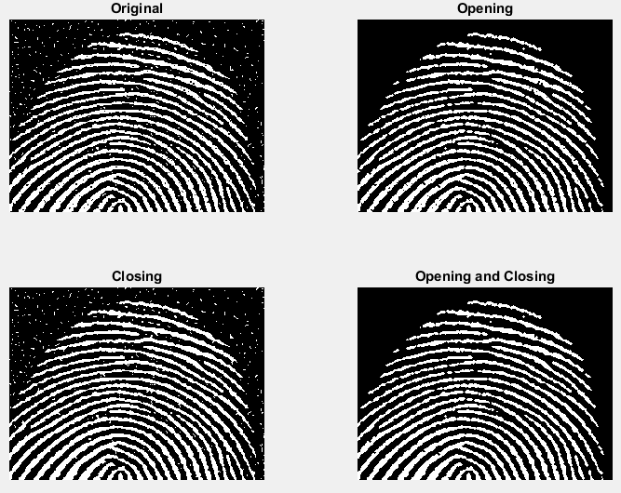Figure 8: Solution to Question 5 (for noisy-fingerprint-text.tif)

